Final – NYC Arrests Analysis
ALY 6070: Communication and Visualization for Data Analytics
Date: 08/13/2025
Instructor: Professor Jack Bergersen
Term: Summer 2025
Group 2:
Ruman Liu
Junhui Hu

Introduction
In this project, we explored the 2023 NYPD Arrest Data in New York City to address a few research questions about crime patterns in NYC. In particular, we were interested in seeing the distribution of offenses by borough, age group, race, and over time to uncover any potentially interesting insights that can be used to inform public safety strategies and initiatives.
Here is the list of research questions we explore in the dataset:
1. Which borough has the highest arrest counts? What are the top 5 offense types there?
2. What are the top 5 offense types in each age group?
3. How do different boroughs compare when accounting for their populations in arrest rates?
4. How do crime rates change over time in the city?
5. Which races have arrest rates above the city average? Which have arrest rates below?
To answer these questions, we explored the data in Tableau and created a set of visualizations that directly address each research question. This included sourcing external data in addition to the raw arrest count information such as borough population statistics and creating calculated fields to perform simple statistical operations to, for example, normalize arrest counts by population or classify categories as above or below an average value.
The final delivery for this project is an interactive dashboard that includes multiple visualizations. For each visualization, we made an effort to provide the most direct and unambiguous answer to a particular research question using a carefully considered set of design choices that account for clarity, accuracy, and understandability for viewers who are not familiar with advanced statistics.
Analysis
Research Question 1 ：Which borough in New York City has the highest number of arrests, and what are the most common offense types in those areas?
The purpose of this analysis is to identify crime hotspots in New York City and determine the most prevalent offense types in those areas. Such information is critical for optimizing resource allocation, including police deployment and community safety programs.
Method. The dataset used in this analysis was the NYPD Arrest Data for 2023. The key variables were ARREST_BORO (borough where the arrest occurred) and OFNS_DESC (offense description). A Tableau dashboard was created using two visualizations: (1) a bubble map, where bubble size represented the arrest count and color represented the borough, and (2) a horizontal stacked bar chart showing the top three offense types for each borough. The map and bar chart were combined into a single dashboard to facilitate side-by-side comparison.
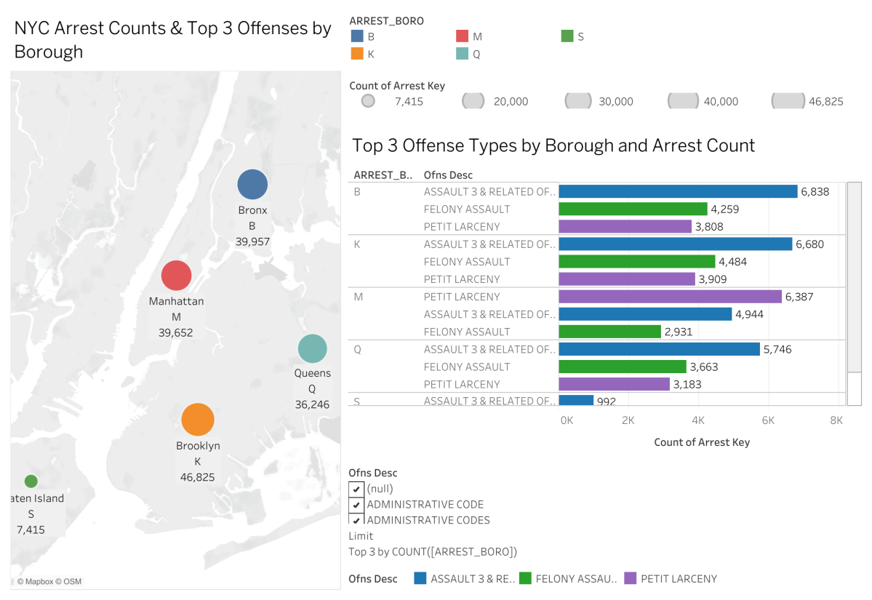
Figure 1 :Dashboard showing NYC arrest counts and top 3 offense types by borough (2023).
Note. Bubble size represents total arrest count; colors represent borough. Data source: NYPD Arrest Data (2023).
Findings. Brooklyn (K) recorded the highest number of arrests (46,825), followed by the Bronx (B; 39,957) and Manhattan (M; 39,652). Across most boroughs, the three most common offenses were Assault 3 & Related Offenses, Felony Assault, and Petit Larceny. The prevalence of violent offenses, especially in Brooklyn and the Bronx, suggests a need for targeted law enforcement strategies and community-based prevention programs.
Interpretation. The data clearly identifies Brooklyn as the primary crime hotspot in NYC. Given the concentration of both violent crimes and property crimes, policymakers should consider increasing patrol presence, expanding violence prevention initiatives, and investing in theft deterrence measures in this borough.

Research Question 2 ：What are the top 5 offense types for different age groups in NYC arrests (2023)?
The purpose of this analysis is to explore how criminal behavior patterns vary by age group, in order to inform age-specific crime prevention and intervention strategies.
Method. The dataset used was the NYPD Arrest Data for 2023. The key variables were AGE_GROUP (age category of the arrestee) and OFNS_DESC (offense description). A stacked bar chart was created in Tableau showing arrest counts for each age group, with color-coded bars representing the five most common offense types. The chart allows for a direct comparison of offense patterns across different age categories.
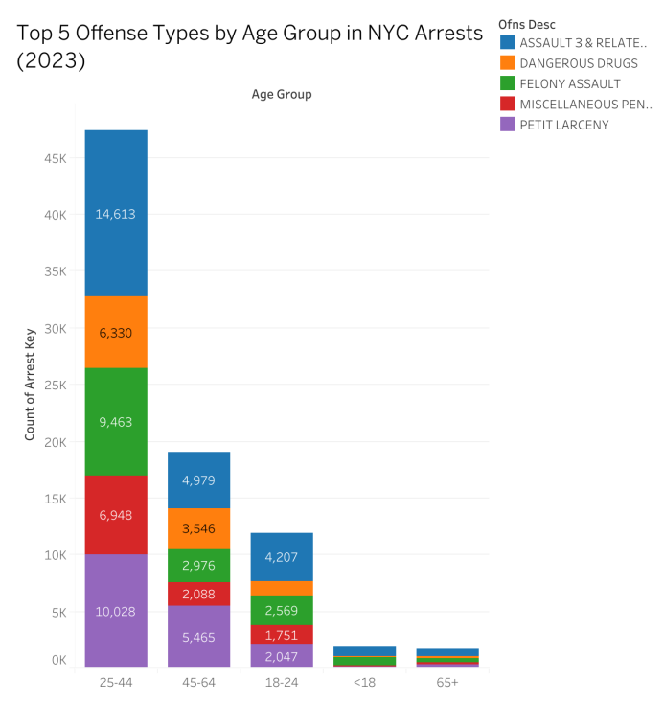
Figure 2：Top 5 offense types by age group in NYC arrests (2023).
Note. Colors represent offense types; bar height represents arrest counts. Data source: NYPD Arrest Data (2023).
Findings. The 25–44 age group recorded the highest arrest counts overall, with Petit Larceny (10,028 arrests) and Assault 3 & Related Offenses (14,613 arrests) being the most prevalent crimes. The 45–64 age group had lower total arrests but followed a similar pattern, with Petit Larceny and Assault 3 & Related Offenses leading. The 18–24 group showed a higher proportion of Assault 3 & Related Offenses and Dangerous Drugs. For individuals under 18, Robbery was disproportionately high compared to other offenses. The 65+ group had very low arrest counts, with Petit Larceny being the most frequent offense.
Interpretation. These results suggest that mid-adult offenders (25–44) drive the majority of arrests in NYC, primarily for theft and assault-related offenses. For youths under 18, targeted programs to address robbery and violent behavior may be effective, while older adult crime prevention could focus on reducing theft incidents.

Research Question 3
The question I was looking to answer is how do crime rates vary by borough. I wanted to show how many crimes occur in each borough of New York City. However, since the boroughs have varying populations, I could not just count the number of arrests, but instead had to normalize by population. The variables were thus Borough to segment by area, Arrest Key to have a unique count per event, and Population from the external source that was joined to the arrests data. The data challenge was that after the join, the population repeated on every row that shared the same borough key. Summing this column would be incorrect as it would grossly overstate the population. However, I knew that the correct population was there, so I could use the average or the min function to derive that value from within the arrest data. From here, the measures were easily built. Since I needed to show percentage (total arrests / total population), and "per X" value ("people per crime"), both are straightforward aggregation functions using the existing columns. The findings are that the Bronx has the highest rate of crime in 2023 in both % and how often a crime occurs per person. Staten Island, which had some arrests, was the lowest compared to its population and thus the least "crime-dense" borough. The difference this made from a simple count of raw values is that the rates show a story different than what some may have expected based on volume alone. The choice of a table is to show this data, as it is far more likely that the exact number would be read and interpreted than to understand an area in a graph, for example. The two metrics were thus placed next to each other, with short column headings and consistent formatting. I did not use additional color or fluff since this does not serve the interpretation of a table of numbers. This kept to a simple, data-forward design.
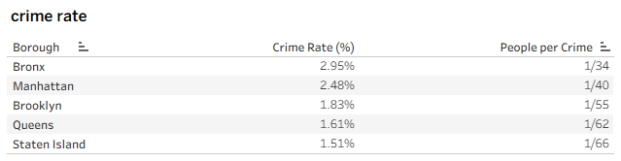
Research Question 4
To examine arrests by month, I needed to manipulate date information. The fields I used were Arrest Date (converted to months only), Borough (to separate into different series), and Arrest Key (to count different arrests made). I created a line chart with the months (My PC system is Chinese, so month is set to Chinese by default) along the x-axis, and the number of arrests along the y-axis. The first version of this chart included all of the boroughs in the same view, with the same scale along the y-axis. This made it look like Staten Island's data was a flat line because the y-axis was calibrated to the variation of larger boroughs like Brooklyn and the Bronx. To exaggerate each borough's pattern, I turned on the option for independent y-axes on each row of the small multiple view. Now the variation in each borough is rescaled relative to itself. The data for each borough is much more readable with this configuration. The takeaway from this chart is that the number of arrests in each borough does not vary too much during the year. There is not an explosion of arrests during any one month or a cliff where arrests disappear. There are minor seasonal spikes, with a couple around the middle of the year that might be associated with summer activity, but these are slight. I chose a line chart because this geometry is very clearly about continuity and change over time. I used different colors for each borough to help the reader follow a single borough without getting mixed up. I also kept the chart light and uncluttered with few gridlines, month labels on the x-axis, and clean type. The goal was for the chart to make its point immediately: arrests occur year-round, but the rate of arrests in each borough is relatively constant with minor seasonal variation.
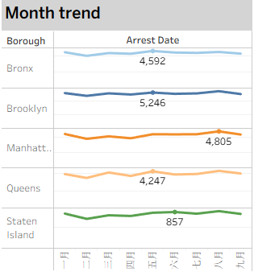

Research Question 5
In looking at how arrest rates differ between races, I mainly worked with the Perp Race field to group people into demographic categories, and I used the count of Arrest Key to find each group’s share of all arrests. Rather than just putting the percentages into a table, I wanted to compare them visually against one standard – the citywide average arrest rate. To do this, I made a simple calculated field that tagged each race as “Above Avg” or “Below Avg,” depending on whether its share was higher or lower than the overall mean. It was not a complicated formula, just a logical check comparing one value to the average. The chart I chose was a dot plot, with every point standing for one race, placed along a horizontal scale showing the arrest rate. I added a vertical reference line to mark the citywide average, so it acted as a clear divider between the two categories. The points were colored according to their label, which made it quick to see which races were above or below without having to read every number. From this view, it was clear that Black and White Hispanic groups were above the average, while others like Asian/Pacific Islander and White were below. This style was cleaner than a crowded table and helped focus attention on how each group lined up against the overall city rate. Keeping the design simple—just one axis, the reference line, and the colored points—made the answer to the research question stand out right away.
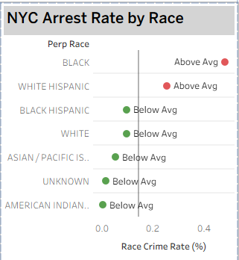

Conclusion
This dashboard offers a broad view of NYC arrests in 2023 and then breaks it down by geography, age, and race. The analysis of the data shows that, while Brooklyn has the most arrests overall, the Bronx has the highest crime rate. This shows that how you measure crime can make a difference. For example, looking at total crimes can give you one pattern, but adjusting for population size can tell a different story. Analyzing arrests over time, the study found that most types of arrests in NYC stay relatively constant, with only slight increases or decreases at certain times of the year. The report on race and arrests found that while some racial groups had lower rates of arrests, Black and White Hispanic populations were above average.
The design of the dashboard helps to make sense of this by organizing the findings in a way that makes them easy to read and understand. The visualization uses maps, bar charts, tables, line graphs, and dot plots. These visualizations work together to provide an overview of the data that can be seen briefly, but which can also be analyzed in detail. The calculated fields in this study are used not only for statistical reasons but also for human-readability. For example, by calculating “people per crime” instead of simply crime rates. This shows that designing metrics thoughtfully can also help make them easier to understand. Overall, this case study is a good example of how data visualizations can be used to make complex information easy to understand and could be a useful foundation for more specific applications like improving policing and prevention programs in the future. The same methodology could be applied to additional years of data to find trends or to look at socioeconomic indicators in addition to crime.

Reference
POPULATION ESTIMATES FOR NEW YORK CITY AND BOROUGHS AS OF JULY 1, 2023. https://www.nyc.gov/assets/planning/download/pdf/planning-level/nyc-population/population-estimates/current-population-estimates-2023-June2024-release.pdf?r=1&utm_source=chatgpt.com
Urban Audit city factsheets for 2019 Urban Adaptation Map Viewer, European Environment Agency, 2019. https://public.tableau.com/app/profile/european.environment.agency/viz/test_20190116Urban_vulnerability_ideasFR_0/mainpage
NYC Department of City Planning. (2024). Current Population Estimates. https://www.nyc.gov/assets/planning/download/pdf/planning-level/nyc-population/population-estimates/population-trends-2023-Jun2024-release.pdf

